**Android App for Flower Vista**

**TECHNICAL REPORT**



**SUBMITTED BY**

Ali Raza

2020-AG-6362

**ADVISED BY**

Dr. Nayyar Iqbal

**A TECHNICAL REPORT SUBMITTED IN PARTIAL FULFILLMENT OF REQUIREMENT FOR THE DEGREE**

BACHELOR OF SCIENCE

IN

COMPUTER SCIENCE

**DEPARTMENT OF COMPUTER SCIENCE**

**FACULTY OF SCIENCES**

**UNIVERSITY OF AGRICULTURE FAISALABAD**

**2024**

**DECLARATION**

I hereby declare that the contents of the report “**Flower Vista**” are project of my own research and no part has been copied from any published source. I further declare that this work has not been submitted for award of any other diploma/degree. The university may take action if the information provided is found false at any stage. In case of any default the scholar will be proceeded against as per UAF policy.

_________________

Ali Raza

2020-ag-6362

**CERTIFICATE**

To,

The Controller of Examinations,

University of Agriculture,

Faisalabad.

The supervisory committee certify that **Ali Raza, 2020-ag-6362** has successfully completed his project in partial fulfillment of requirement for the degree of BS Computer Scienceunder our guidance and supervision.

_____________________________________

Dr. Nayyar Iqbal

Assistant Professor/Advisor

_______________________________________

Dr. Muhammad Ahsan Latif

Chairman,

Department of Computer Science

**ACKNOWLEDGEMENT**

I would like to express my gratitude to everyone who has contributed to the completion of this report. Firstly, I am thankful to the Almighty for His blessings and guidance throughout this journey. I am also grateful to the Department of Computer Science for providing me with the opportunity to pursue my studies here. A special thanks goes to my supervisor, Dr. Nayyar Iqbal, whose guidance and encouragement have been invaluable. His support and challenges have played a significant role in bringing this work to fruition. Any shortcomings in this report are solely my responsibility. I would also like to extend my appreciation to the individuals who participated in my research. Their assistance and openness greatly facilitated my work. Additionally, I am thankful to my fellow students for their constructive feedback, which has contributed to the improvement of this project.

**ABSTRACT**

Flower Vista is a mobile application developed using HTML, CSS, JavaScript (JS), Typescript (TS), Tailwind CSS, React Native, Firebase, Context, and various other libraries. This app aims to simplify the process of buying and selling flowers through a user-friendly interface accessible on mobile devices. Key features include a comprehensive flower catalog, seamless order placement, and efficient delivery tracking. Firebase integration ensures secure authentication and real-time data management. Through iterative development and user feedback, Flower Vista offers a reliable solution for floral transactions, highlighting the potential of mobile technology to revolutionize traditional marketplaces.

Table of Contents

Chapter 1 INTRODUCTION 5

1.1 Background 5

1.2 Description 5

1.3 Problem Statement 5

1.4 Scope 5

1.5 Objectives 6

1.6 Feasibility 6

1.7 Requirements 7

1.7.1 Functional Requirements 7

1.7.2 Non- Functional Requirements 7

1.7.3 Hardware Requirements 8

1.7.4 Software Requirements 8

1.8 Stakeholders 8

Chapter 2 MATERIALS & METHODS 9

2.1 Process Model 9

2.2 Tools & Technologies 9

2.3 Design: 9

2.3.1 Use Case Diagrams 10

2.3.3 Sequence Diagram 16

2.3.4 Class Diagram 19

2.3.5 Data Flow Diagram 20

2.3.6 ER Diagram 24

2.3.7 Database Model 24

2.3.8 Architecture 25

Chapter 3 RESULTS & DISCUSSION 27

3.1 Testing 27

3.2 Test Cases 27

3.3 Conclusion 29

Chapter 4 Conclusion 30

User Manual 31

References 37

List of Figures

Figure ‎1.1 Stakeholders 6

Figure ‎2.1 Agile Activities 7

Figure 2.‎2 Use Case Diagram 11

Figure 2.3 Sequence Diagram 16

Figure ‎2.4 Level 0 DFD 17

Figure 2.5 Level 1 DFD 17

Figure 2.6 Level 2 DFD 18

Figure ‎2.7 Entity Relationship Diagram 24

Figure ‎1 Navigation Diagram 26

Figure ‎2 All Category Diagram 27

Figure 3 Product Detail Diagram 28

Figure ‎4 Sign Up and Sign In Diagram 30

Figure ‎5 Order Details Diagram 31

Figure ‎6 Add Product Diagram 33

List of Tables

Table 2. 3: Buyer Adds Product to Cart……………………………………………………. ……13

Table 2. 4: Order Review and Checkout 14

Table 2. 5: Seller Adds New Product Listing 14

Table 2. 6: Seller Updates Product Listing 15

Table 2. 7: Seller Deletes Product Listing 16

Table 3. 1: Buyer Login with Valid Username and Password 20

Table 3. 2: Buyer Browse Products by Category……………………...........................................21

Table 3.3: Buyer Add Product to Cart………………………………………………...................21

Table 3.4: Buyer View All Products (No Filter Selected)……………………………………….22

Table 3.5: Buyer Checkout Process with Valid Billing Information…………………………….22

Table 3.6: Seller Add New Product……………………………………………………………...23

Table 3.7: Seller Update Product Information…………………………………………………...24

Table 3.8: Seller Remove Product from Inventory………………………………………………24

Table 3.9: Seller View Order Details…………………………………………………………….25

# CHAPTER 1

# INTRODUCTION

## 1.1 Background

## In today's digital age, online platforms have become increasingly popular for purchasing goods and services, and the floral industry is no exception. However, the process of buying and selling flowers can still be cumbersome and inefficient, often lacking a centralized platform for transactions. This gap in the market presents an opportunity to develop a mobile application that streamlines the floral purchasing process, catering to the needs of both customers and florists.

## The Flower Vista project aims to address these challenges by providing a user-friendly platform for buying and selling flowers. By leveraging the power of mobile technology and integrating modern development tools and frameworks such as HTML, CSS, JavaScript (JS), Typescript (TS), Tailwind CSS, React Native, Firebase, and Context, Flower Vista seeks to revolutionize the floral marketplace.

## Through the development of Flower Vista, the project team aims to create a solution that offers convenience, accessibility, and reliability to users worldwide. By providing a centralized platform for floral transactions, Flower Vista will not only simplify the process of buying and selling flowers but also foster a sense of community and connection within the floral industry.

## 1.2 Description

## Flower Vista is a cutting-edge mobile application designed to transform the landscape of flower commerce. At its core, Flower Vista comprises two integral components: an intuitive admin dashboard and a user-friendly panel tailored to meet the diverse needs of both administrators and customers.

## The admin dashboard serves as a central control center, empowering administrators to efficiently manage the app's inventory and operations. Through this dashboard, administrators can seamlessly add new flowers to the catalog, categorize them based on various criteria such as type or occasion, and furnish comprehensive details including name, price, description, and images. This streamlined approach ensures that the catalog remains up-to-date and well-organized, enhancing the overall user experience.

## On the user panel front, Flower Vista presents customers with an engaging interface designed to simplify the flower shopping process. Users are greeted with a visually appealing layout showcasing an array of flower options. They can effortlessly browse through the catalog, explore different categories, and access detailed information about each flower, including pricing and descriptions. Additionally, users can take advantage of special offers and discounts to optimize their shopping experience.

## When users find the perfect flower, Flower Vista facilitates a seamless checkout process. Users can swiftly add desired items to their cart and proceed to checkout, where they can review their selections and finalize their purchase. The app also offers convenient delivery options, allowing users to specify their preferred delivery date and provide recipient details. This user-centric approach ensures a hassle-free shopping experience while enabling efficient order fulfillment for administrators.

## 1.3 Problem Statement

## The flower industry currently lacks a centralized platform for efficient and user-friendly buying and selling transactions. Florists and customers face challenges in accessing a comprehensive catalog of flowers, managing orders, and facilitating seamless transactions. Existing solutions are often fragmented and fail to provide a cohesive experience, resulting in inefficiencies and frustrations for both parties involved.

## Initiating the Flower Vista project requires a thorough reality check to assess the feasibility and necessity of the proposed solution. The primary goal is to define and justify the implementation of a mobile application that addresses the specific issues faced by florists and customers in the flower commerce domain. By identifying the key pain points and challenges, the project aims to deliver a solution that enhances the overall experience for users and streamlines the process of buying and selling flowers.

## 1.4 Scope

The scope of the Flower Vista project encompasses the development and implementation of a mobile application aimed at revolutionizing the flower commerce industry. This includes the creation of two primary components: an admin dashboard and a user panel, each serving distinct purposes to meet the needs of administrators and customers.

The admin dashboard will facilitate efficient management of the app's inventory and operations. Administrators will be able to add, categorize, and update flowers in the catalog, as well as manage orders and track sales. Additionally, the admin dashboard will provide analytics and reporting features to monitor the performance of the application.

On the user panel side, the focus will be on providing a seamless and user-friendly shopping experience for customers. Users will have access to a comprehensive catalog of flowers, with detailed descriptions and images. They will be able to browse, search, and filter flowers based on various criteria, as well as take advantage of special offers and discounts.

The scope also includes implementing features such as a secure authentication system, a streamlined checkout process, and customizable delivery options for users. Furthermore, the project will involve integrating third-party services such as Firebase for backend functionality and Tailwind CSS for responsive design.

It is crucial to document and define the project scope to ensure alignment between the project team and stakeholders. This scope statement will serve as a solid agreement outlining the expected work effort, features, and functions of the Flower Vista application, ultimately guiding the project to successful completion.

* 1. **Objectives**

To develop and deploy Flower Vista, a mobile application designed to revolutionize the flower commerce industry.

* Develop an intuitive admin dashboard for efficient management of the application's inventory and operations.
* Implement a user-friendly user panel to provide customers with a seamless shopping experience.
* Create a comprehensive catalog of flowers, including detailed descriptions and images. Enable users to browse, search, and filter flowers based on various criteria. Integrate a secure authentication system to safeguard user data and transactions.

## Implement a streamlined checkout process for users to purchase flowers easily.

## Provide customizable delivery options, allowing users to specify preferred delivery dates and recipient details.

## Integrate third-party services such as Firebase for backend functionality and Tailwind CSS for responsive design.

## Conduct thorough testing to ensure the application's reliability, security, and performance.

## Deploy Flower Vista on both iOS and Android platforms, following respective guidelines and standards.

## Feasibility

Followings are the feasibilities of Flower Vista:

**1.6.1 Technical Feasibility**

The technical feasibility study will assess whether the project team has the necessary technological resources, skills, and expertise to undertake the development of the Flower Vista application. It will also evaluate whether the existing processes and procedures are conducive to project success.

**1.6.2 Schedule Feasibility**

The schedule feasibility study will determine whether the project can be completed within the available time frame. It will assess the team's current workload and commitments to ensure that sufficient time resources are allocated to the Flower Vista project.

**1.6.3 Economic Feasibility**

The economic feasibility study, also known as the cost/benefit analysis, will evaluate whether the project is financially viable. It will consider the financial resources of the company/team and assess whether the benefits of the project outweigh the costs.

**1.6.4 Cultural Feasibility**

The cultural feasibility study will examine the impact of the project on both local and general cultures. It will also assess any environmental implications of the project to ensure compliance with cultural and environmental standards.

**1.6.5 Legal/Ethical Feasibility**

The legal/ethical feasibility study will identify any legal implications of the project and evaluate ethical considerations. It will ensure that the project meets all legal and ethical requirements before proceeding.

**1.6.6 Resource Feasibility**

The resource feasibility study will assess whether the project has access to the necessary resources, including human resources, facilities, and equipment. It will identify any resource constraints and determine the resource requirements for the project.

**1.6.7 Operational Feasibility**

The operational feasibility study will evaluate how well the project team will be able to solve problems and take advantage of opportunities that arise during the project. It will assess the team's ability to effectively implement and manage the Flower Vista application.

## Requirements

Requirements of the Flower Vista is as follows:

* + 1. **Functional Requirements**

Functional requirements are as follows:

**FR01: User Authentication**

FR01-01: The system shall request username and password from the user.

FR01-02: The system should authenticate the provided username and password.

FR01-03: Upon successful authentication, the system shall allow the user to log in.

FR01-04: If authentication fails, the system shall display a message prompting the user to contact the admin for assistance.

**FR02: Flower Management**

FR02-01: The system shall allow the admin to add new flowers to the catalog.

FR02-02: The system shall enable the admin to categorize flowers based on type, category, or price range.

FR02-03: The system shall provide fields for the admin to enter details such as name, price, description, and images for each flower.

**FR03: Shopping Features**

FR03-01: Users shall be able to browse through the catalog and view detailed information about each flower.

FR03-02: Users shall have the option to add flowers to their cart for purchase.

FR03-03: The system shall calculate the total bill amount based on the selected flowers.

FR03-04: Users shall be prompted to provide delivery details, including the preferred delivery date and recipient information, during checkout.

**1.7.2 Non-Functional Requirements**

**NFR01: Availability**

NFR01-01: The system shall remain available 24/7 to users.

**NFR02: User Types**

NFR02-01: The system shall support two types of users: admin and client.

**NFR03: User Guidance**

NFR03-01: The system shall provide tooltips for every option/button to enhance user understanding and navigation.

**1.7.3 Hardware Requirements**

* Processor: Pentium(R) Core i3 CPU or higher
* Hard Disk: 40GB or more
* RAM: 4GB or more

**1.7.4 Software Requirements**

Operating System: Android (Version 8.0 and above), iOS (Version 9 and above)

Browser: N/A (App-based platform.

**1.7.5** **Stakeholders**

The stakeholders involved in the Flower Vista project encompass a diverse range of individuals and groups with vested interests in the development, deployment, and utilization of the mobile application. These stakeholders include the development team responsible for the design and implementation of the application, the project manager overseeing its progress and resources allocation, and the admin users tasked with managing the inventory and operations within the application. Additionally, clients and end-users form a crucial stakeholder group, as they are the primary beneficiaries of the application, utilizing it to browse, select, and purchase flowers. Quality assurance teams ensure the application meets high standards, while marketing teams promote its adoption. Customer support teams assist users with inquiries and issues, legal and compliance teams ensure adherence to regulatory requirements, and management provides overall direction and support for the project. Each stakeholder plays a vital role in the success and effectiveness of the Flower Vista project, ensuring alignment with objectives and meeting the needs of all involved parties. Figure 1.1 Stakeholders represents figure [1].

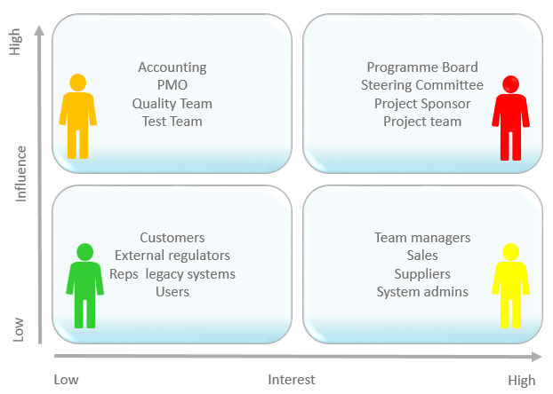

**Figure 1.1**: Stakeholders

# CHAPTER 2

# MATERIALS & METHODS

## 2.1 Process Model

For the Flower Vista project, the chosen process model is Agile. Agile methodology is selected due to its suitability for dynamic and iterative development processes, making it an ideal fit for our project requirements.

Agile is characterized by its incremental and iterative approach, where development occurs in short, time-boxed iterations known as sprints. This allows for rapid delivery of functional components, which are then integrated to create a working prototype. The Agile model promotes collaboration between cross-functional teams, encourages frequent communication, and prioritizes customer feedback.

In the context of Flower Vista, the Agile model enables the development team to quickly respond to changing requirements and incorporate feedback from stakeholders. By breaking down the project into manageable tasks and delivering them in iterations, Agile facilitates early and continuous delivery of valuable software. This approach aligns with the project's goals of creating a user-friendly and feature-rich mobile application for buying and selling flowers.

Moreover, Agile methodology fosters flexibility and adaptability, enabling the project team to make adjustments as needed throughout the development lifecycle. This is particularly beneficial in the context of a dynamic and evolving market landscape, where responsiveness to customer needs and market trends is paramount. Figure 2.1 Agile Activities represents figure [2].

**Figure 2.1:** Agile Activities

* 1. **Tools & Technologies**

In the development of Flower Vista, the following tools and technologies were utilized: Visual Studio Code served as the integrated development environment (IDE) for coding and debugging, offering a versatile platform for developers. React Native was employed for building native mobile applications using JavaScript and React, ensuring a seamless user experience across different devices. Firebase provided comprehensive backend services, including authentication, database management, and hosting, which streamlined the development process. HTML and CSS were used for designing user interfaces, ensuring they are both visually appealing and functional. JavaScript (JS) and TypeScript (TS) were essential for implementing client-side logic and interactivity, enhancing the app's responsiveness and performance. Tailwind CSS, a utility-first CSS framework, facilitated rapid building of custom designs, allowing for a consistent and efficient styling process. Git and GitHub were crucial for version control, enabling the team to track changes, manage versions, and collaborate effectively. Adobe XD was used to create detailed wireframes, interactive prototypes, and user interface designs, providing a clear visual guide for development. Additionally, Postman was utilized as an API development and testing tool, facilitating efficient interaction with backend services and ensuring robust API performance. These tools and technologies collectively contributed to the creation of a high-quality, scalable, and user-friendly mobile application.

## 2.3 Design

The design of the Flower vista is this:

**2.3.1 Use Case Diagram**

In the development of Flower Vista, the use case diagram is essential for illustrating user interactions with the system. It highlights the roles of customers and administrators, showing how customers can browse flowers, view details, add items to the cart, and make purchases. For administrators, it outlines tasks like managing inventory, updating flower details, processing orders, and handling user queries. This diagram provides a clear blueprint for developers, ensuring all features are implemented to meet user needs and deliver a seamless experience. It also helps identify areas for improvement and streamline workflows, contributing to the app's overall success.

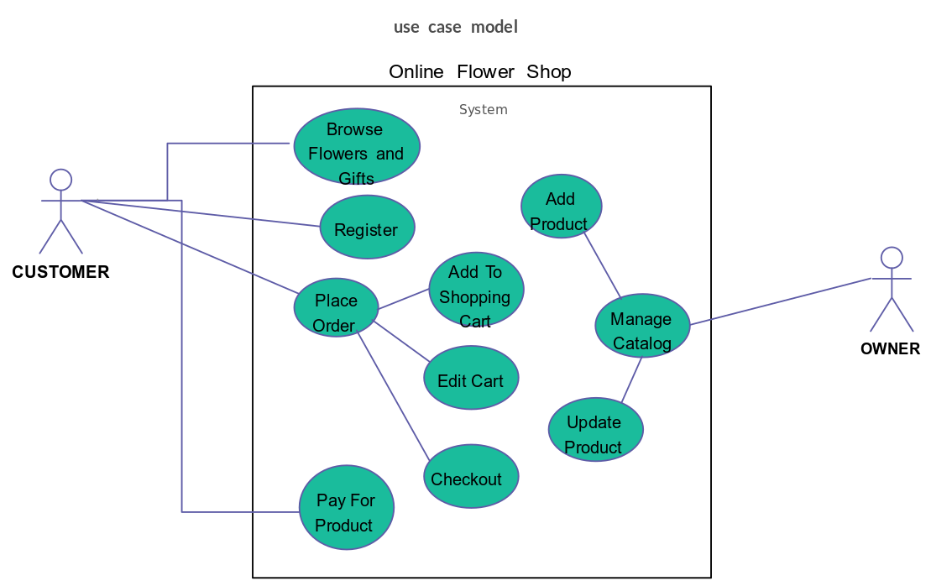



**Figure 2.2:** Use Case Diagram

**2.3.2 Usage Scenario**

**Table 2.1:** User Creates New Account

|  |  |  |
| --- | --- | --- |
| Use Case Title | Buyer Creates New Account | |
| Use Case Id | 1 | |
| Requirement Id | 1 | |
| Description: This use case describes the scenario where a new Buyer registers for an account on the Flower Vista Mobile App. | | |
| Pre-Conditions:  Buyer has access to a web browser and internet connection.  Buyer has a valid email address. | | |
| Task Sequence | |  |
| 1. Buyer navigates to the "Register" or "Sign Up" page on the Flower Vista Mobile App. | |  |

|  |
| --- |
| 1. Buyer navigates to the "Register" or "Sign Up" page on the Flower Vista. |
| 1. System displays a registration form requiring user information. This may include fields for:  * Full Name * Email * Password * Confirm Password |
| 1. Buyer clicks the "Register" or "Create Account" button. |
| 1. System validates the entered information. This may involve checks for:  * Valid email address format * Strong password criteria (minimum length, complexity) * Matching passwords in "Password" and "Confirm Password" fields |

**Table 2.2:** Buyer Browse Products

|  |  |  |
| --- | --- | --- |
| Use Case Title | Buyer Browse Products | |
| Use Case Id | 2 | |
| Requirement Id | 2 | |
| Description: This use case describes how a Buyer can browse and search for products on the Flower Vista | | |
| Pre-Conditions:  Buyer has access to the product listing page. | | |
| Task Sequence | |  |
| System displays the product listing page. | |  |
| Buyer utilizes search and filter options to narrow down product selection. | |  |
| Buyer clicks on a product listing to view product details. | |  |
| Buyer navigates through product listings and details pages to explore available products. | |  |
| Post Conditions:   * + Buyer is able to browse and search for products based on their needs. | | |
| Unresolved issues: None mentioned. | | |
| Authority: System Administrator (for product management) | | |
| Modification history: 1.0  Author: Flower Vista | | |

**Table 2.3:** Buyer Adds Product to Cart

|  |  |  |
| --- | --- | --- |
| Use Case Title | Buyer Adds Product to Cart | |
| Use Case Id | 3 | |
| Requirement Id | 3 | |
| Description: This use case describes how a Buyer can add a product to their shopping cart. | | |
| Pre-Conditions:  Buyer has browsed product listings.  Buyer has selected a desired product. | | |
| Task Sequence | |  |
| Buyer locates the "Add to Cart" button on the product details page.  Buyer clicks the "Add to Cart" button.  System displays a confirmation message indicating the product has been added to the cart. | |  |
| Buyer utilizes search and filter options to narrow down product selection. | |  |
| Buyer clicks on a product listing to view product details. | |  |
| Buyer navigates through product listings and details pages to explore available products. | |  |
| Post Conditions:   * + The selected product is added to the Buyer's shopping cart. | | |
| Unresolved issues: None mentioned. | | |
| Authority: System Administrator | | |
| Modification history: 1.0  Author: Flower Vista | | |

**Table 2.4:** Order Review and Checkout

|  |  |  |
| --- | --- | --- |
| Use Case Title | Order Review and Checkout | |
| Use Case Id | 4 | |
| Requirement Id | 4 | |
| Description: This use case describes how a Buyer places an order after reviewing the details. | | |
| Pre-Conditions:  Buyer has reviewed their order details on the checkout page. | | |
| Task Sequence | |  |
| Buyer select product quantity. | |  |
| Buyer clicks the "Place Order" button. | |  |
| Post Conditions: | | |
| Unresolved issues: None mentioned. | | |
| Authority: System Administrator | | |
| Modification history: 1.0  Author: Flower Vista | | |

**Table 2.5:** Seller Adds New Product Listing

|  |  |  |
| --- | --- | --- |
| Use Case Title | Seller Adds New Product Listing | |
| Use Case Id | 5 | |
| Requirement Id | 6 | |
| Description: This use case describes how a Seller can create a new product listing on the marketplace. | | |
| Pre-Conditions:  Seller has a registered Seller account.  Seller has access to the product listing creation page.  Seller has information about the product they want to list, including:   * Flower Category * Flower Name * Description * Category * Price * Stock quantity * Images | | |
| Task Sequence | |  |
| Seller navigates to the "Add Product" page. | |  |
| System displays a product listing form. This form may include fields for:   * Product name * Detailed product description (including key features and benefits) * Category selection from a dropdown menu (e.g., Fruits, Vegetables, Dairy) * Price per unit * Initial stock quantity | |  |
| Seller enters all required information and uploads product images. | |  |
| Seller submits the product listing. | |  |
| Post Conditions:   * + A new product listing is created for the Seller's product on the marketplace. | | |
| Unresolved issues: None mentioned. | | |
| Authority: System Administrator | | |
| Modification history: 1.0  Author: Flower Vista | | |

**Table 2.6:** Seller Updates Product Listing

|  |  |  |
| --- | --- | --- |
| Use Case Title | Seller Updates Product Listing | |
| Use Case Id | 6 | |
| Requirement Id | 6 | |
| Description: This use case describes how a Seller can update an existing product listing on the marketplace.. | | |
| Pre-Conditions:  Seller has a registered Seller account.  Seller has an existing product listing they want to modify.  Seller has access to the product listing management section in their Seller dashboard. | | |
| Task Sequence | |  |
| Seller navigates to the "Category Page". | |  |
| System displays a list of the Seller's product listings. | |  |
| Seller enters all required information and uploads product images. | |  |
| Seller locates the product listing they want to update. | |  |
| Seller clicks the "Edit" button associated with the chosen product. | |  |
| Seller modifies the desired product information. This may involve changes to:   * Product name * Description * Category * Price * Stock quantity | |  |
| Seller submits the changes. | |  |
| Post Conditions:   * + The Seller's existing product listing is successfully updated with the new information. | | |
| Unresolved issues: None mentioned. | | |
| Authority: System Administrator | | |
| Modification history: 1.0  Author: Flower Vista | | |

**Table 2.7:** Seller Deletes Product Listing

|  |  |  |
| --- | --- | --- |
| Use Case Title | Seller Deletes Product Listing | |
| Use Case Id | 7 | |
| Requirement Id | 6 | |
| Description: This use case describes how a Seller can remove an existing product listing from the marketplace. | | |
| Pre-Conditions:  Seller has a registered Seller account.  Seller has an existing product listing they want to delete.  Seller has access to the product listing management section in their Seller dashboard. | | |
| Task Sequence | |  |
| Seller navigates to the "My Product" Page. | |  |
| System displays a list of the Seller's product listings. | |  |
| Seller locates the product listing they want to delete. | |  |
| Seller clicks the "Delete" button associated with the chosen product. | |  |
| System displays a confirmation message. | |  |
| Post Conditions:   * + The Seller's chosen product listing is successfully deleted from the marketplace. | | |
| Unresolved issues: None mentioned. | | |
| Authority: System Administrator | | |
| Modification history: 1.0  Author: Flower Vista | | |

### 

### 2.3 Sequence Diagram

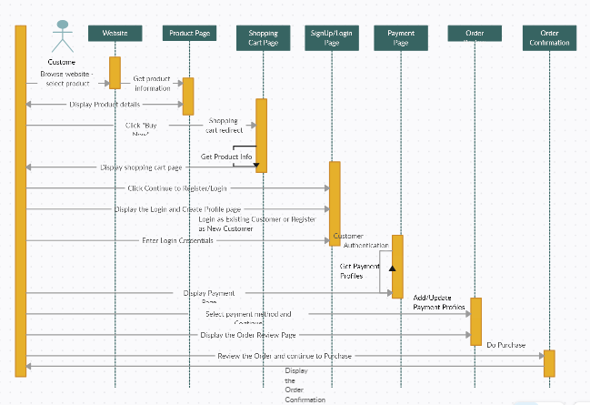

**Figure 2.3:** Sequence Diagram

### 2.3.4 Data Flow Diagram

**Level 0**

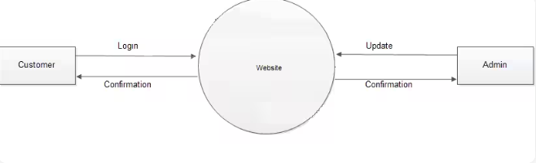

Flower Vista

**Figure 2.4:** Level 0 DFD

**Level 1**

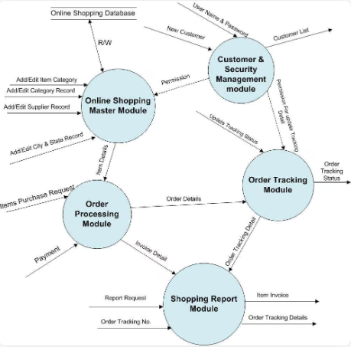

**Figure 2.5:** Level 1 DFD

**Level 2**

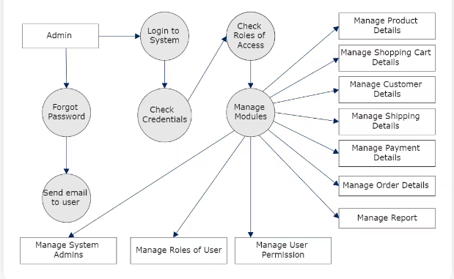**figure 2.6:** Level 2 DFD

# CHAPTER 3

# RESULTS & DISCUSSION

## 3.1 Testing

Software testing is the process of evaluating the functionality of the web application against the defined requirements. It aims to identify defects, verify if the application meets specifications, and ultimately deliver a high-quality product. There are two key aspects of software testing:

* **Verification:** This ensures the application is built according to the requirements and specifications documented in Chapter 1. Testing verifies if the features function as intended and produce the expected results.
* **Validation:** This broader concept assesses if the application meets the actual needs of its users. Validation testing might involve user testing to see if the application is intuitive, user-friendly, and addresses the core problems it's designed to solve.

## 3.2 Test Cases

**Table 3.1:** Buyer Login with Valid Username and Password

|  |  |
| --- | --- |
| Test Case ID: | TC-1 |
| Test Case Title: | Buyer Login with Valid Username and Password |
| Test Case Priority: | Medium |
| Requirement: | User Login |
| Test Description: | This test verifies the user login process. |
| Test Date: | 05/14/2024 |
| Pre-Conditions: | 1. Run the application.  2. Click Sign in button. |
| Dependencies: | Internet Availability |
| Test Steps: | 1. Enter Valid user name and password and click Login  2. Click Sign Out  2. Without entering user name click sign in  3. Without entering password click sign in  4. Enter wrong password or user name and click sign in |
| Test Data | Email id and password of user |
| Expected Results: | 1. System should open home page.  2. Login page should be displayed.  2. An error message should be shown to enter user name  3. An error message should be shown to enter password  4. Error message should be shown to enter correct password and user id |
| Actual Results: | As above |
| Post Conditions: | System shows Dash board page of signed in user. In case of unauthorized sign in attempt system shows the message “Invalid username/password”. |
| Status: (Pass/Fail) | Pass |

**Table 3.2:** Buyer Browse Products by Category

|  |  |
| --- | --- |
| Test Case ID: | TC-2 |
| Test Case Title: | Buyer Browse Products by Category |
| Test Case Priority: | Medium |
| Requirement: | Product Filtering Functionality |
| Test Description: | This test case verifies a Buyer's ability to browse products by selecting a specific category using radio buttons. |
| Test Date: | 05/14/2024 |
| Pre-Conditions: | 1. Run the application. |
| Dependencies: | Internet Availability |
| Test Steps: | 1. Go to the Organic Farming Marketplace product listing page.  2. Locate the category filter section with radio buttons for each product category.  3. Select a desired category radio button (e.g., Fruits, Vegetables). |
| Test Data | None |
| Expected Results: | 1. The product listing page should dynamically update to display only products belonging to the selected category.  2. Product listings should include relevant details like product name, image, and price. |
| Actual Results: | As above |
| Post Conditions: | None |
| Status: (Pass/Fail) | Pass |
| Other Comments: | None |

**Table 3.3:** Buyer Add Product to Cart

|  |  |
| --- | --- |
| Test Case ID: | TC-3 |
| Test Case Title: | Buyer Add Product to Cart |
| Test Case Priority: | High |
| Requirement: | REQ-301 (Shopping Cart Functionality) |
| Test Description: | This test case verifies a Buyer's ability to add a product to their shopping cart. |
| Test Date: | 05/14/2024 |
| Pre-Conditions: | 1. Run the application.  2. Click Sign in button. |
| Dependencies: | Internet Availability |
| Test Steps: | 1. Go to the product listing page for a desired product.  2. Click the "Add to Cart" button for the product. |
| Test Data | None |
| Expected Results: | 1. A confirmation message should be displayed indicating the product has been added to the cart.  2. The shopping cart icon should update to reflect the number of items added. |
| Actual Results: | As above |
| Post Conditions: | None |
| Status: (Pass/Fail) | Pass |
| Other Comments: | None |

**Table 3.4:** Buyer View All Products

|  |  |
| --- | --- |
| Test Case ID: | TC-4 |
| Test Case Title: | Buyer Add Product to Cart |
| Test Case Priority: | Low |
| Requirement: | REQ-202 (Product Filtering Functionality) |
| Test Description: | This test case verifies that when no category radio button is selected, all available products are displayed. |
| Test Date: | 05/14/2024 |
| Pre-Conditions: | 1. Run the application.  2. Click Sign in button. |
| Dependencies: | Internet Availability |
| Test Steps: | 1. Go to the Organic Farming Marketplace product listing page.  2. Leave all category radio buttons unselected. |
| Test Data | None |
| Expected Results: | 1. The product listing page should display all available products from all categories. |
| Actual Results: | As above |
| Post Conditions: | None |
| Status: (Pass/Fail) | Pass |
| Other Comments: | None |

**Table 3.5:** Buyer Checkout Process with Valid Billing Information

|  |  |
| --- | --- |
| Test Case ID: | TC-5 |
| Test Case Title: | Buyer Checkout Process with Valid Billing Information |
| Test Case Priority: | High |
| Requirement: | Checkout |
| Test Description: | This test case verifies a Buyer's ability to successfully complete the checkout process with valid billing information. |
| Test Date: | 05/14/2024 |
| Pre-Conditions: | 1. Run the application.  2. Click Sign in button. |
| Dependencies: | Internet Availability |
| Test Steps: | 1. Login as a Buyer with a cart containing desired products.  2. Proceed to the checkout page.  3. Enter valid billing and shipping information.  4. Click the "Place Order" button. |
| Test Data | None |
| Expected Results: | 1. An order confirmation page should be displayed with order details. |
| Actual Results: | As above |
| Post Conditions: | None |
| Status: (Pass/Fail) | Pass |
| Other Comments: | None |

**Table 3.6:** Seller Add New Product

|  |  |
| --- | --- |
| Test Case ID: | TC-6 |
| Test Case Title: | Seller Add New Product |
| Test Case Priority: | High |
| Requirement: | (Product Addition Functionality) |
| Test Description: | This test case verifies a Seller's ability to add a new product to their inventory. |
| Test Date: | 05/14/2024 |
| Pre-Conditions: | 1. Run the application.  2. Login as a Seller. |
| Dependencies: | Internet Availability |
| Test Steps: | 1. Navigate to the product management section in the Seller dashboard.  2. Click on the option to add a new product.  3. Fill in the required product details (name, description, price, quantity, etc.).  4. Upload product images, if required.  Save the new product. |
| Test Data | New product details (name, description, price, etc.) |
| Expected Results: | 1. The new product should be successfully added to the Seller's inventory.  2. The product should be visible in the product listing. |
| Actual Results: | As above |
| Post Conditions: | None |
| Status: (Pass/Fail) | Pass |
| Other Comments: | None |

**Table 3.7:** Seller Update Product Information

|  |  |
| --- | --- |
| Test Case ID: | TC-7 |
| Test Case Title: | Seller Update Product Information |
| Test Case Priority: | Medium |
| Requirement: | (Product Information Modification) |
| Test Description: | This test case verifies a Seller's ability to update the information of an existing product in their inventory. |
| Test Date: | 05/14/2024 |
| Pre-Conditions: | 1. Run the application.  2. Login as a Seller. |
| Dependencies: | Internet Availability |
| Test Steps: | 1. Navigate to the product management section in the Seller dashboard.  2. Locate the product to be updated.  3. Edit the product details (description, price, quantity, etc.).  4. Save the changes. |
| Test Data | Updated product details (description, price, etc.) |
| Expected Results: | 1. The product information should be successfully updated in the Seller's inventory.  2. The changes should be reflected in the product listing. |
| Actual Results: | As above |
| Post Conditions: | None |
| Status: (Pass/Fail) | Pass |
| Other Comments: | None |

**Table 3.8:** Seller Remove Product from Inventory

|  |  |
| --- | --- |
| Test Case ID: | TC-8 |
| Test Case Title: | Seller Remove Product from Inventory |
| Test Case Priority: | High |
| Requirement: | (Product Removal Functionality) |
| Test Description: | This test case verifies a Seller's ability to remove a product from their inventory. |
| Test Date: | 05/14/2024 |
| Pre-Conditions: | 1. Run the application.  2. Login as a Seller. |
| Dependencies: | Internet Availability |
| Test Steps: | 1. Navigate to the product management section in the Seller dashboard.  2. Locate the product to be removed.  3. Click on the option to delete/remove the product.  4. Confirm the deletion. |
| Test Data | None |
| Expected Results: | 1. The product should be successfully removed from the Seller's inventory.  2. The product should no longer appear in the product listing. |
| Actual Results: | As above |
| Post Conditions: | None |
| Status: (Pass/Fail) | Pass |
| Other Comments: | None |

**Table 3.9:** Seller View Order Details

|  |  |
| --- | --- |
| Test Case ID: | TC-9 |
| Test Case Title: | Seller View Order Details |
| Test Case Priority: | Medium |
| Requirement: | (Order Details Access for Sellers) |
| Test Description: | This test case verifies a Seller's ability to view details of an order placed by a Buyer. |
| Test Date: | 05/14/2024 |
| Pre-Conditions: | 1. Run the application.  2. Login as a Seller. |
| Dependencies: | Internet Availability |
| Test Steps: | 1. Navigate to the order management section in the Seller dashboard.  2. Click order history button and navigate to order history page.  3. See buyer detail and order detail. |
| Test Data | None |
| Expected Results: | 1. The Seller should be able to view detailed information about the selected order, including items, quantities, total price, shipping address, and status. |
| Actual Results: | As above |
| Post Conditions: | None |
| Status: (Pass/Fail) | Pass |
| Other Comments: | None |

**Software Results**

|  |  |  |  |  |  |  |  |  |
| --- | --- | --- | --- | --- | --- | --- | --- | --- |
| **#** | **Customer**  **Name** | **Date** | **Address** | **WhatsApp** | **Flower Category** | **Price Rs** | **Service Type** | **Delivery Type** |
| **1** | **Ali Raza** | **30-5-24** | H#32 Ali Town Lahore | 03212423862 | Red Rose | **300** | **COD** | **Done** |
| **2** | **Fahad** | **2-6-24** | H#2 Amin Town Fsd | 03272423333 | Kali | **499** | **COD** | **Pending** |
| **3** | **Hassan** | **4-3-24** | H#7 Sultani Town Lahore | 03115523862 | Chambelli | **349** | **COD** | **Pending** |
| **4** | **Alia** | **14-5-24** | H#37 Hassan Town Okara | 03212423862 | Chambelli | **349** | **AP** | **Progress** |
| **5** | **Manzoor** | **28-9-24** | H#675 Ellahiabad  Fsd | 03012434765 | Red Rose | **300** | **AP** | **Done** |
| **6** | **Talib** | **11-1-24** | H#90 Tech Town Lahore | 03442876342 | Sunflower | **179** | **COD** | **Done** |
| **7** | **Mubeen** | **29-2-24** | H#2 Raja Town Pindi | 03338423899 | Gainda | **275** | **COD** | **Pending** |

**Figure:** Flower Vista Results

# CHAPTER 4

# CONCLUSION

This project has documented the development process for the Flower Vista Mobile Application, an e-commerce platform for selling flowers. By leveraging modern technologies and a well-defined development approach, we've established a robust and user-friendly foundation for a successful online marketplace. Embracing the Agile methodology allowed us to continuously integrate user feedback and adjust functionalities based on evolving needs. Utilizing React Native, Tailwind CSS, Firebase, Redux, and Axios, we've created a powerful and efficient development environment that is performant, scalable, and maintainable. Comprehensive testing ensured the application meets both functional and non-functional requirements, delivering a smooth and intuitive user experience.

The Flower Vista Mobile Application has the potential to significantly impact the flower sales industry. It provides local sellers with a direct sales channel to reach a wider consumer base, potentially increasing their income and market access, thereby contributing to a more vibrant local economy. Consumers gain access to a variety of fresh flowers at competitive prices while connecting directly with sellers, fostering transparency and trust. This empowers consumers to make informed choices about their purchases, potentially supporting sustainable and ethical practices. Additionally, by shortening the supply chain, the application can contribute to a more sustainable flower market with reduced transportation distances, leading to lower carbon emissions and a smaller environmental footprint. In conclusion, the Flower Vista Mobile Application demonstrates how modern technology can create efficient, user-friendly, and impactful digital solutions, supporting local sellers, empowering consumers, and promoting sustainability in the flower sales industry.

**USER MANUAL**

**Navigation Bar**

The navigation bar, located at the top of most pages, provides easy access to key sections of the application:

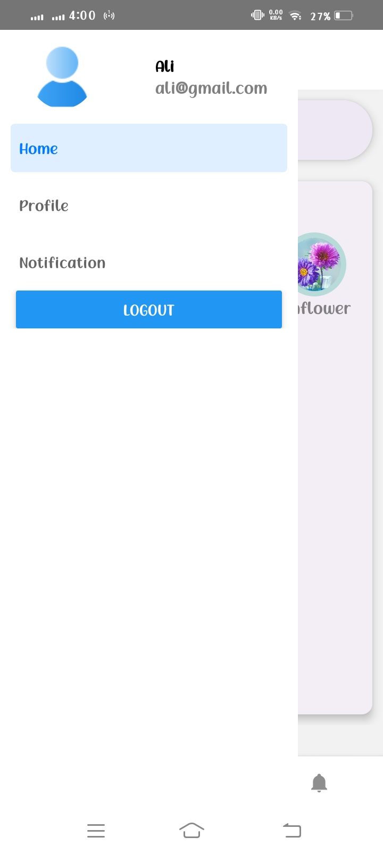

**Figure 1:** Navigation Bar

* **Home:** This is the landing page of the application. It typically showcases Home, Flowers, user Profile, highlights from, and provides an overview of the platform's purpose.
* **Profile:** This section provides information about the details of the user profile. It might also explain the benefits of supporting local Sellers and the importance of sustainable Flower selling practices.
* **Place Order:** This section provides Order information for the Placed order. Here you might find an item name, phone number, Category, Price and some more information about the product. Figure 4.1 Navigation Bar represents figure [3].

### Browsing Products

The Products page allows you to explore the diverse offerings available from local farms. Here's how to navigate this section:

* **Product Listings:** Products are typically displayed in a grid or list format, showcasing essential information like product name, a representative image, and potentially the farm that cultivates it.

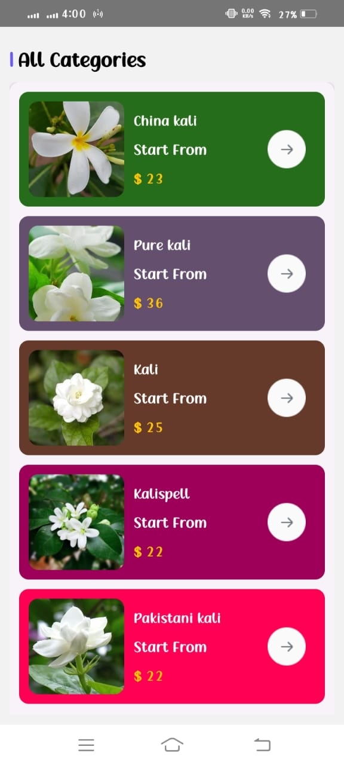

**Figure 2:** Categories

### Product Details

The product detail page offers a zoomed-in view of each farm-fresh product. Here's what you'll find:

* **Product Image:** A high-quality image that entices you with product freshness.
* **Product Name:** Clear and easy to identify.
* **Description:** Details like origin, variety, and any special features.
* **Price:** Unit price displayed prominently.
* **Quantity (Optional):** Choose the amount you want to buy (e.g., pounds of apples).
* **"Add to Cart" Button:** Add your selection to your virtual shopping basket (login might be required).

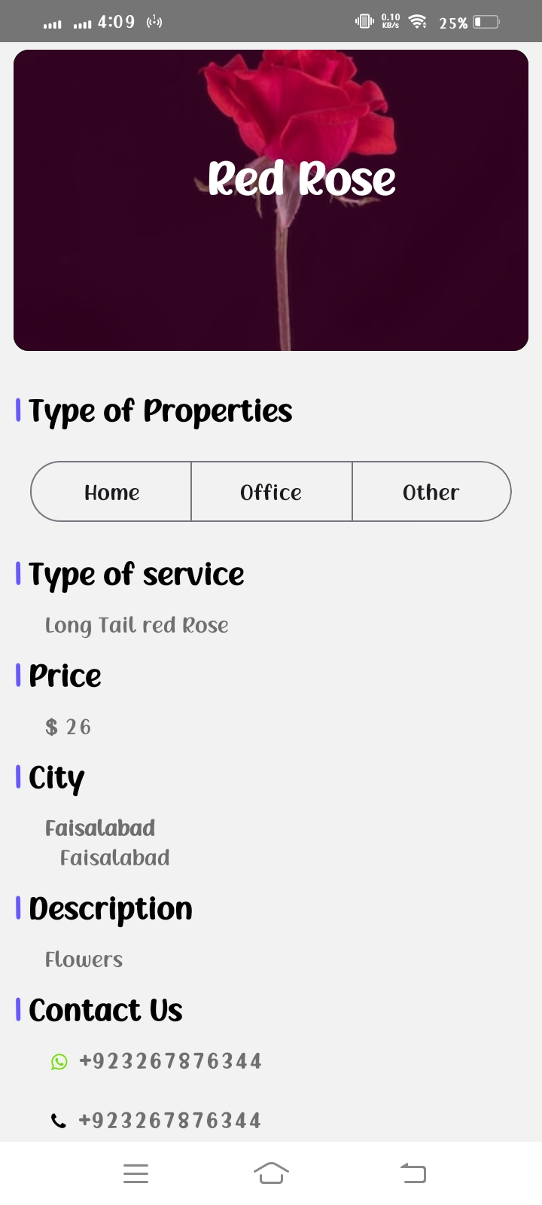

**Figure 3:** Product details

### Sign In

Before you can fill your virtual basket with fresh, local goodies, you'll need to log in to your Flower Vista account. Here's how:

* **Locate Sign In:** Look for the "Sign In" section, typically positioned at the top corner of most Flower Vista pages.
* **Enter Credentials:** Carefully fill in the following fields:
  + **Email:** Enter the email address associated with your Flower Vista.
  + **Password:** Enter your registered password for your Flower Vista.
* **Click “Sign In”:** Once you've entered your credentials, click the designated "Sign In" button.
* **Login Required for Adding Products:** **Important Note:** Flower Vista requires users to be logged in before adding products to their cart. This ensures a smooth checkout process and personalizes your shopping experience.

**Successful Login:** If your email and password match Flower Vista records, you'll be successfully logged in. You'll likely be redirected to the homepage you were trying to access, now with the ability to add products to your cart.

**Don't Have an Account?** If you're new to Flower Vista, signing up is quick and easy. Look for a "Sign Up" option near the login section. By registering, you'll gain full access to Flower Vista features, including adding products to your cart and enjoying a seamless shopping experience.

### Sign Up

The core information required for signing up on the Flower Vista typically includes:

* **Name:** Enter your full name. This information is used for personalization and may appear on your account profile.
* **Email:** This is a crucial field. Enter a valid email address that you check regularly. This will be your primary login credential and may be used for communication from Flower Vista.
* **Password:** Create a strong password that you can easily remember. Here are some tips for creating a strong password:
  + Use a combination of uppercase and lowercase letters, numbers, and symbols.
  + Avoid using easily guessable information like your birthday or pet's name.
  + Make it at least 8 characters long, with more characters being even better.
* **Confirm Password:** Re-type the password you created in the previous field. This ensures you haven't made any typos during password creation

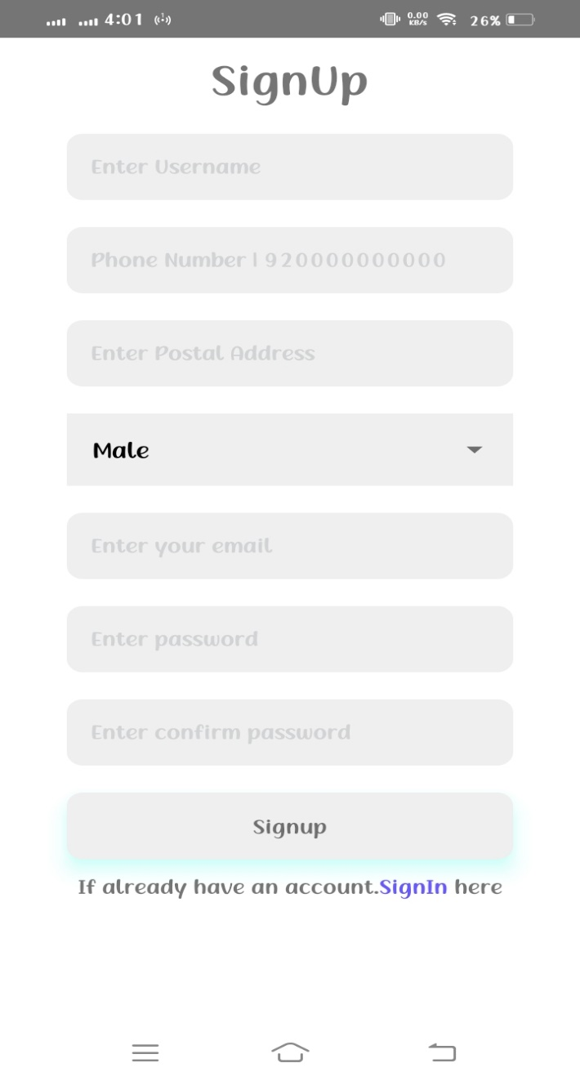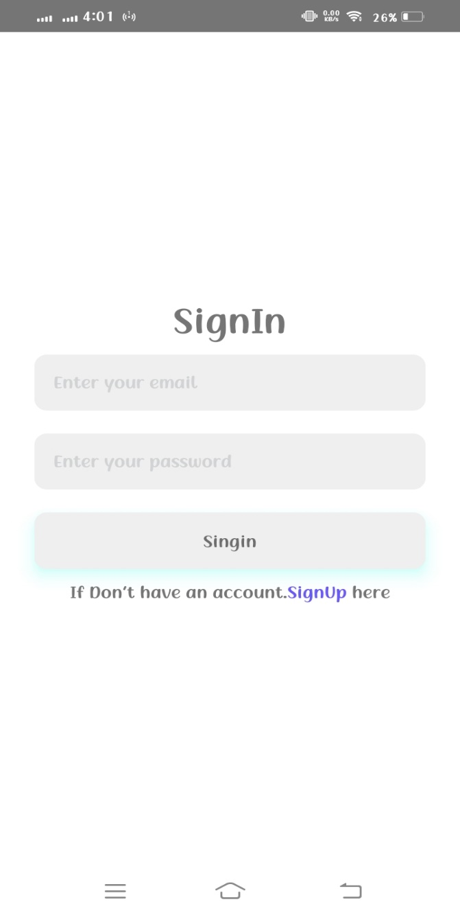

**Figure 4:** Signing up**Figure 5:** Sign in

### Shopping Cart

The shopping cart on Flower Vista is your virtual basket, where you accumulate your desired local farm-fresh products before checkout. Here's how it works:

**Adding Products**

* As you browse the Products page on Flower Vista, you'll typically find an "Add to Cart" button next to each product. Clicking this button adds the chosen product and quantity (if applicable) to your virtual cart.
* Some products might allow you to specify the quantity you desire before adding them.

**Viewing Your Cart**

* Locate the Shopping Cart icon or link, typically positioned at the top corner of most Flower Vista pages. Clicking this icon brings you to your dedicated shopping cart page.
* This page displays a list of all the products you've chosen, including:
  + Product image
  + Product name
  + Quantity selected (if applicable)
  + Unit price

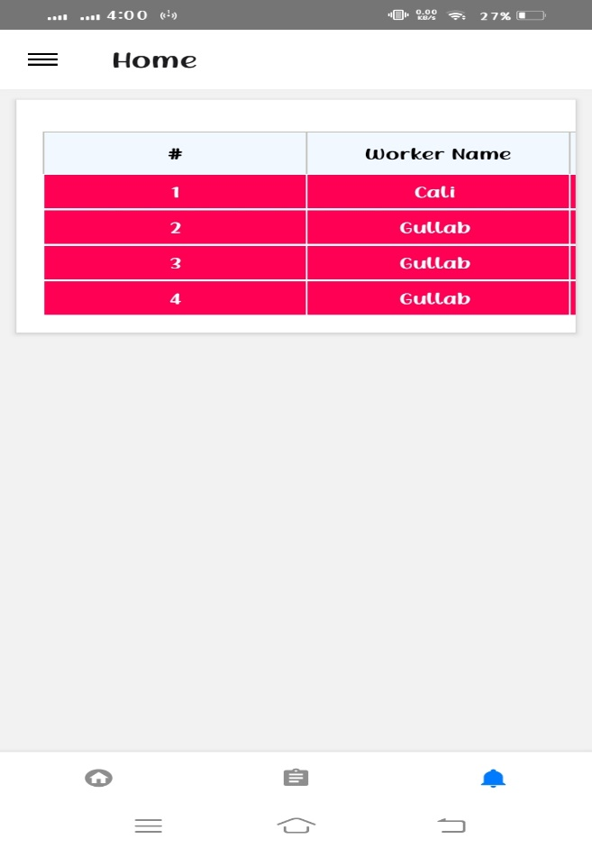

**Figure 6:** Cart Section

### Add Product

The "Add Product" button on your Flower Vista Seller Products page is your gateway to showcasing your fresh offers to a wider audience. Here's a detailed breakdown of the product addition process:

**1. Accessing the Product Creation Tool**

* On your Seller Products page, locate the prominent "Add Product" button. Clicking this button typically redirects you to a dedicated product creation form.

**2. Providing Enticing Details**

* **Product Name:** Craft a clear and descriptive name that accurately reflects your product. Think about keywords customers might use to search.
* **Description:** Write a compelling description that highlights the qualities that set your product apart. Mention origin, variety, selling practices, taste profile, or any unique features that will entice customers (e.g., “Beautiful Flowers with unique look and style”)
* **Category Selection:** Flower Vista might offer pre-defined product categories (e.g. Red Rose, Kali, Sun Flowers). Choose the most relevant category to help customers easily find your offerings while browsing.

**3. Uploading Eye-Catching Images**

* **Visual Appeal is Key:** Upload high-quality images that showcase your product from different angles and in its best light. Consider including close-up shots to highlight freshness and quality. Good visuals can significantly impact customer interest.

**4. Setting the Price**

* **Competitive Pricing:** Establish a competitive and fair price per unit (e.g. per piece or for Bucky). Consider factors like production costs, market rates, and customer value perception.

**5. Inventory Management**

* **Track Your Stock:** Indicate your current stock level for the product. This helps manage customer expectations and avoid overselling. Some platforms might allow you to update inventory levels later as needed.

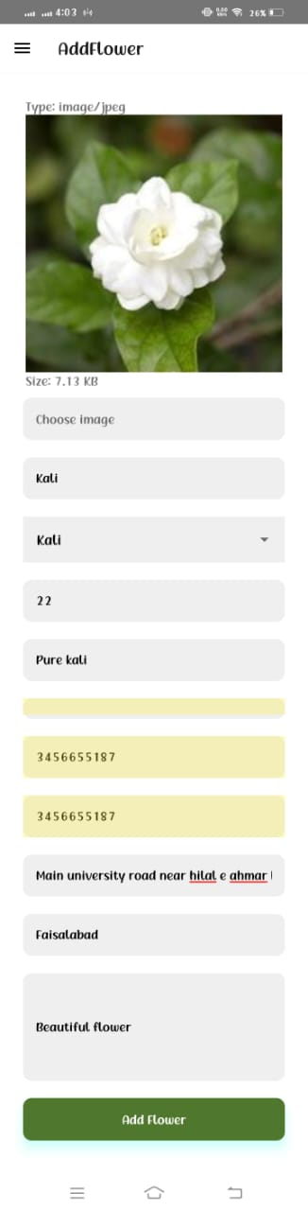

**Figure 7:** Add Flowers

### Order Detail

The Flower Vista order details page equips you, the seller, with all the information you need to fulfill customer orders efficiently. Here's a breakdown of the key elements:

**Customer Details**

* **Customer Name:** Identify the customer who placed the order.
* **Contact Information:** This might include the customer's email address and phone number, allowing you to communicate directly if needed (depending on Flower Vista privacy settings).
* **Delivery Address:** The complete address where the customer wants their order delivered.

**Order Summary**

* **Order Number:** A unique identifier for easy reference.
* **Order Date:** The date and time the order was placed.
* **Order Status:** This indicates the current stage of fulfillment (e.g., "Pending," "Processing," "Complete" "Canceled"). You might be able to update the status here to reflect progress (depending on Flower Vista functionalities).

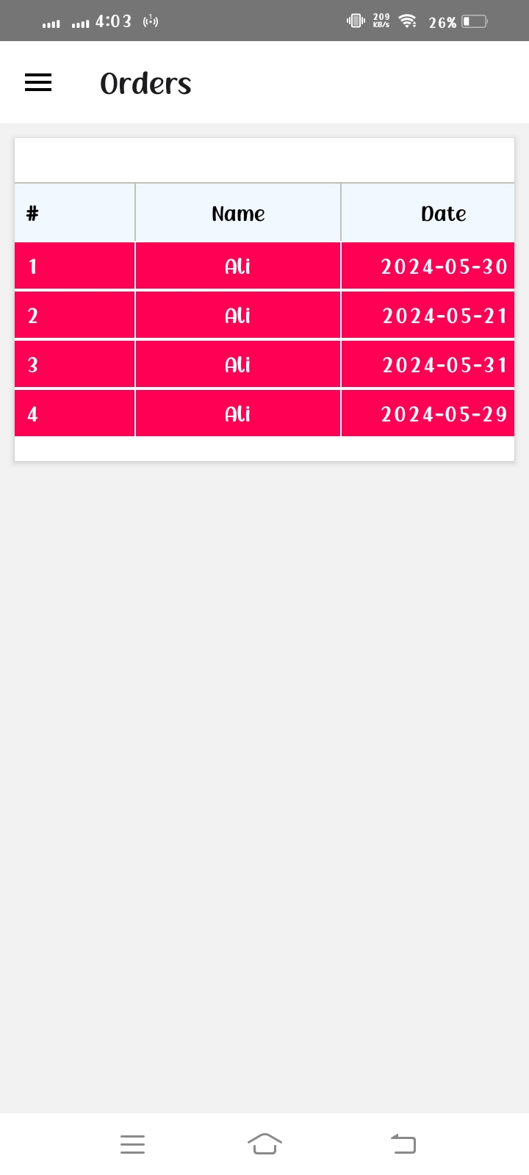

**Figure 8:** Order Details

**References**

[1] https://sophilabs.com/blog/product-inception-stakeholder-analysis

[2] <https://www.google.com/url?sa=i&url=https%3A%2F%2Fwww.slideteam.net%2Fagile->planning-process-with-key

[3] https://reactnative.dev/docs/navigation

[4] https://t.ly/ROiMX